**1.8 Propose Model:**

**1.8.1 Software Model:**

Rapid action development is a software development methodology that uses minimal planning in favor of rapid prototyping and RAD projects follow iterative and incremental model and have small teams comprising of developers, domain experts, customer representatives and other IT resources working progressively on their component or prototype.RAD refers to a development life cycle designed to give much faster development and higher quality systems than the traditional life cycle and it allows usable systems to be built in as little as 60-90 days, often with some compromises.

**1.8.2 Justification:**

* fast application development and delivery
* reducing costs on project whilst not compromising on quality
* reducing the project time-frame and the number of people involved in such project
* encourage the involvement of customers in the entire process of its development lifecycle
* very flexible if any changes required
* visualization of progress
* effective for saving valuable resources
* due to prototyping in nature, there is a possibility of lesser defects
* constant integration isolate problems and encourage customer feedback ensures greater customer satisfaction

**1.9 Related Work Study:**

There are some related works going on E-commerce platform in Bangladesh. A vendor or customer add their products or purchase products and admin are there to maintain the websites like managing vendor and products. In their websites they offer so many products with multiple brands. They are using individual database for maintaining their products where a customer or vendor has to be add their products individually. Here we have given some screenshots of their websites:

**1.9.1 Kiksha.com:**

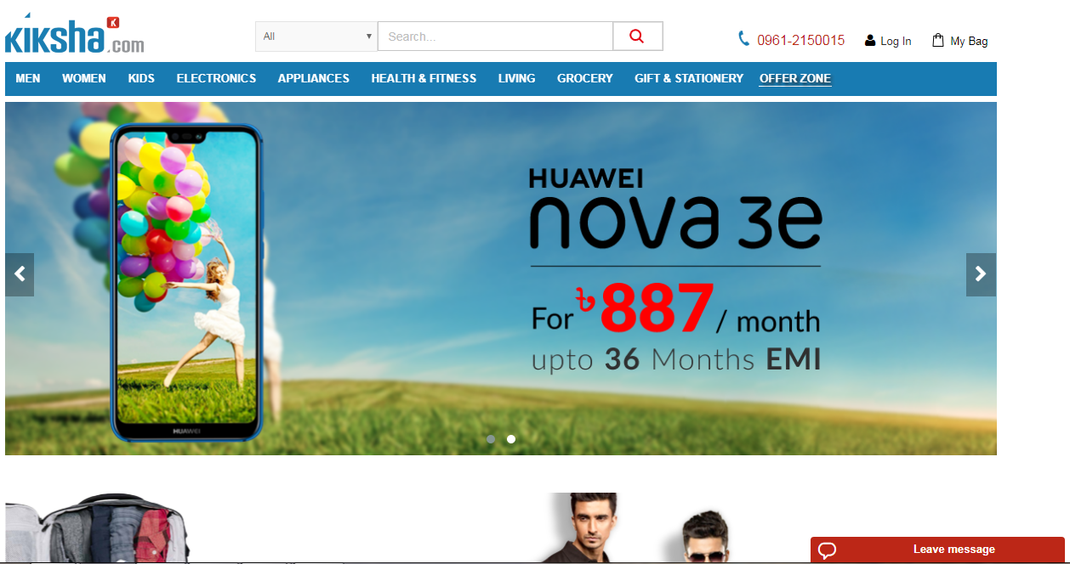

**1.9.2 Daraz.com.bd:**

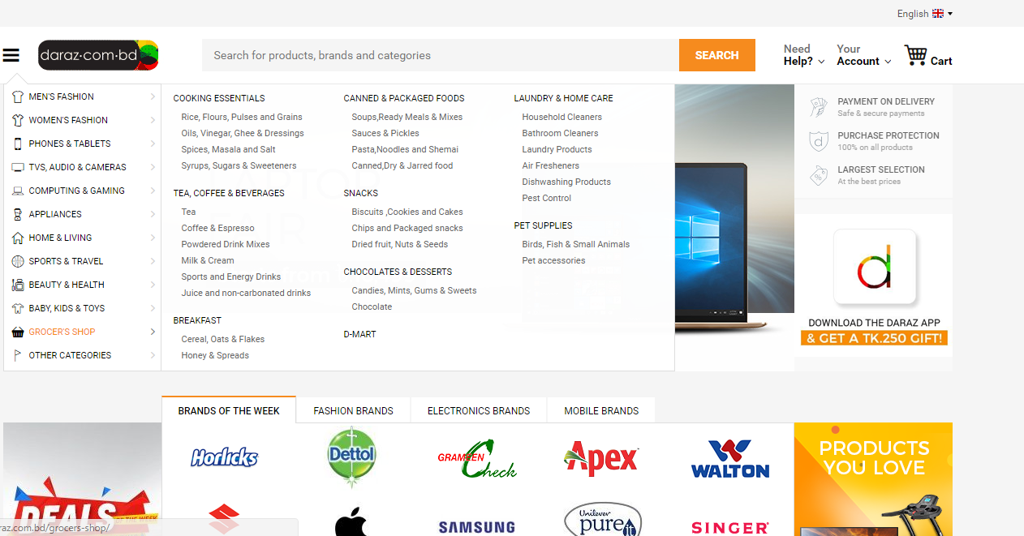

**1.9.3 Bikroy.com:**

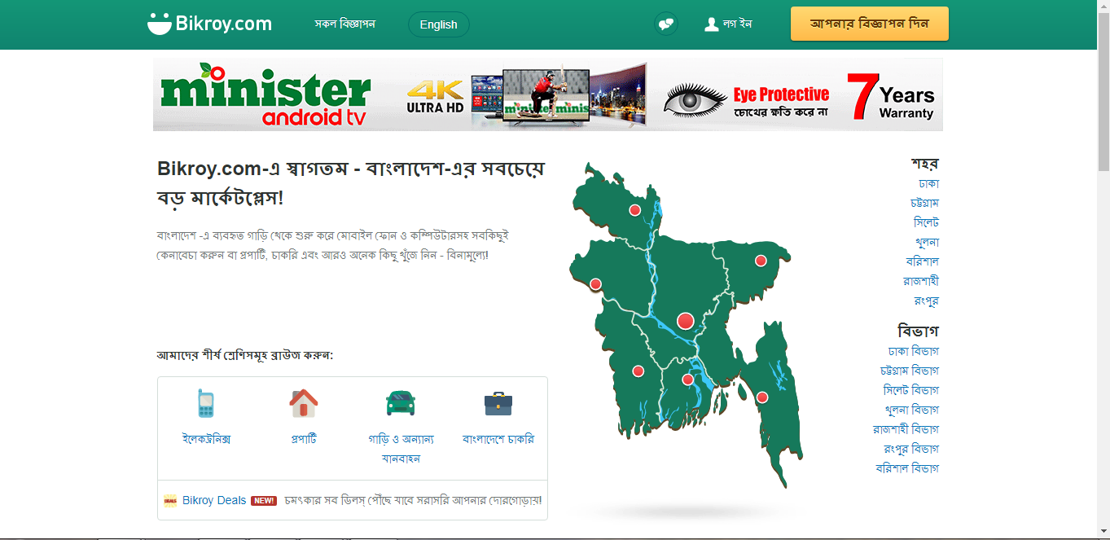

**2.4.3 Interface Requirement:**

Graphical User Inter will be used which will demonstrate the page. GUI will contain all the pages or forms which will be used by users.

**2.4.4 User Interface:**

User interface will be designed based on the users which will contain lots of features. There are two types of users who will use this system. There features will be appear based on their access to the system. They have to login 1st with valid credentials if they want to make any change in the website like admin wants to update the products information and vendor wants to add their products etc.

**2.4.5 Login Page:**

The login page will containing valid credentials option to log into the websites including an email box and password box to enter into the websites. There will be another option for new users who want to create there account.

**2.4.6 Hardware Interfaces:**

**Server Side:**

* OS: Windows/Linux Server
* CPU: Minimum Inter Xenon or higher
* RAM: 4GB or higher
* Hard Disk: 1TB or more

**Client Side:**

* OS (PC): Any operating system with web browsing accessibilities
* CPU (PC): Minimum Inter Pentium or higher
* OS (Android): Any operating system with web browsing accessibilities
* CPU (Android): Adreno 220 or higher
* RAM: 1GB or higher

**2.4.7 Software Interfaces:**

* Database: MySQL
* Programming Language: PHP
* Desing: HTML 5, CSS
* Framework: Laravel
* Development Tool: Notepad++

**2.4.8 Communication Interface:**

* Internet connection

**3.3 System Overview:**

**3.3.1 Use Case:**

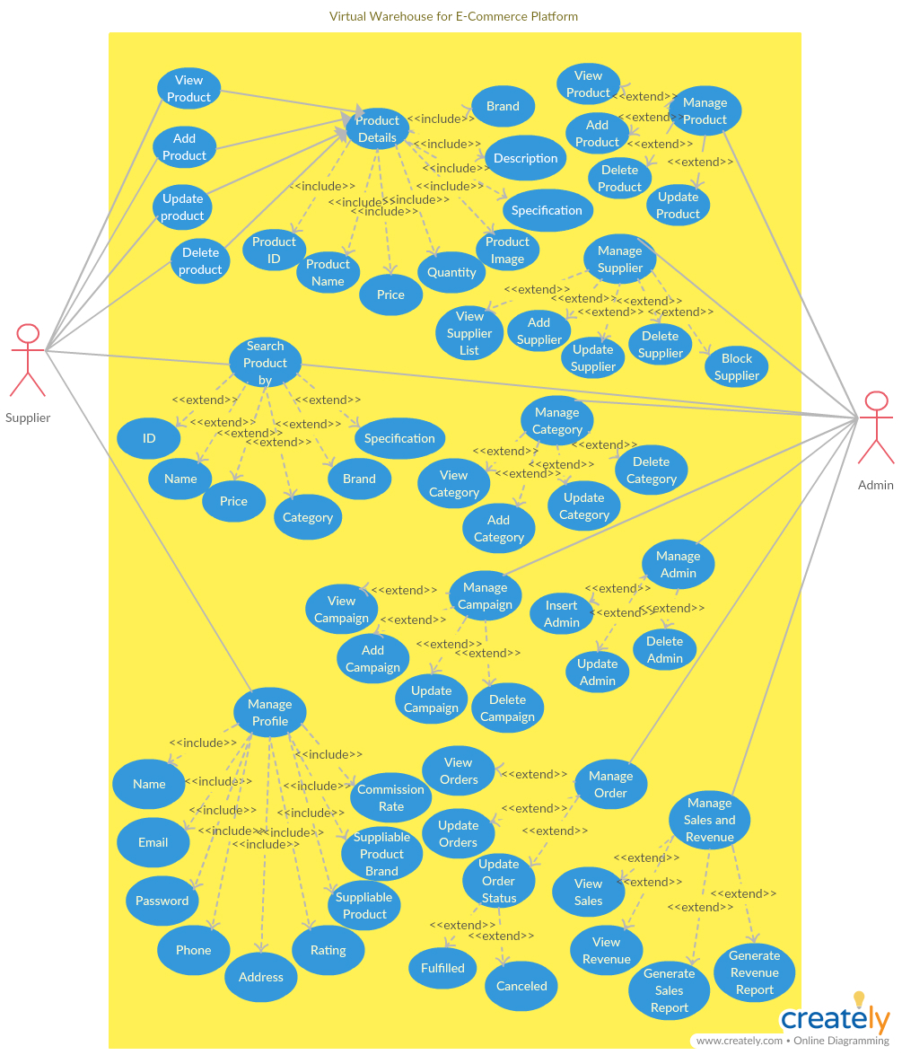

**3.6 Test Plan:**

|  |  |  |  |
| --- | --- | --- | --- |
| No. | Test | Case | Coverage |
| 1 | **Login** | **Check the all text box that accepts texts and numbers** | Check the boxes with valid and invalid input |
| Login with valid credentials successfully |
| Required valid data for Login |
| 2 | **Check the buttons** | Check the Login button |
| Check the SignUp button |
| Check buttons colors and placeholders |
| 3 | **Register** | **Check the all text box that accepts texts and numbers** | Check the boxes with valid and invalid input |
| Store data with successful registration |
| 4 | **Check the buttons** | Check the register button |
| Check the reset button |
| 5 | **Dashboard** | **Vendor dashboard** | Check all the buttons |
| Check all the buttons color |
| Check the vendor dashboard without login |
| 6 | **Admin dashboard** | Check all the buttons |
| Check all the buttons color |
| Check the admin dashboard without login |
| 7 | **Add/Update/Delete Products option of Vendor page** | **Check all the text box that accepts text and numbers individually** | Check the add products option |
| Check the update product option |
| Check the delete product option |
| 8 | **Check the Add/Update/Delete options and drop down boxes** | Check the buttons color |
| Check the buttons works successfully |
| Check the drop down box show properly |
| 9 | **Manage Products option of Admin page** | **Check all the text box that accepts text and numbers individually** | Check the add products option |
| Check the update product option |
| Check the delete product option |
| 10 | **Check the Add/Update/Delete options and drop down boxes** | Check the buttons color |
| Check the buttons works successfully |
| Check the drop down box show properly |
| 11 | **Manage Profile option of Vendor page** | **Check the information** | Check the information properly shown |
| 12 | **Check the Edit button** | Check the information can be edited successfully |
| 13 | **Search Product** | **Check the text box of search option** | Check the box with valid text |
| 14 | **Check the search button** | Check the button works properly after clicked by showing information |
| 15 | **Check the products** | By search with Name |
| By search with Category |
| By search with ID |
| By search with Brand |
| 16 | **Manage Category option of Admin page** | **Check all the text box that accepts text and numbers individually** | Check the add category option |
| Check the update category option |
| Check the delete category option |
| 17 | **Check the Add/Update/Delete options and drop down boxes** | Check the buttons color |
| Check the buttons works successfully |
| Check the drop down box show properly |
| 18 | **Manage Campaign option of Admin page** | **Check the Add/Update/Delete options and drop down boxes** | Check the buttons color |
| Check the buttons works successfully |
| Check the drop down box show properly |
| 19 | **Check all the text box that accepts text and numbers individually** | Check the add campaign option |
| Check the update campaign option |
| Check the delete campaign option |
| 20 | **Manage Admin option of admin page** | **Check the Insert/Update/Delete options and drop down boxes** | Check the buttons color |
| Check the buttons works properly |
| 21 | **Check all the text box that accepts text and numbers individually** | Check the insert Admin option |
| Check the update Admin option |
| Check the delete Admin option |
| 22 | **Manage Orders of Admin page** | **Check the view order option** | Check the view orders option display all the orders after clicking |
| 23 | **Check the update order option** | Check the all the text box accepts text and number |
| Check the order can be update by clicking update button |
| 24 | **Check order status** | Check the status fulfilled or not |
| Check the cancel order button works |
| 25 | **Manage Sales and Revenue of Admin page** | **Check the View Sales** | Check the view sales show the sales of the total properly |
| 26 | **Check the Revenue** | Check the view Revenue show the revenue properly |
| 27 | **Check the sales report and revenue report generate** | Check the report generates successfully |

**Project Management**

**4.1 Project Scheduling:**

|  |  |  |
| --- | --- | --- |
| **No.** | **Task** | **Time(Week)** |
| 1 | Field Study | 0-1 |
| 2 | Study on SDLC | 1-2 |
| 3 | Prepare User Story | 2-3 |
| 4 | Identify User Requirements | 3-5 |
| 5 | Develop Use Case Diagram | 5-7 |
| 6 | Develop Class Diagram | 7-8 |
| 7 | Develop Activity Diagram | 7-8 |
| 8 | Develop ER Diagram | 7-8 |
| 9 | Prototyping | 8-10 |
| 10 | Create Database | 10-11 |
| 11 | Create User Interface | 10-11 |
| 12 | Software Development | 10-18 |
| 13 | Prepare Test Plan | 11-13 |
| 14 | Software Testing | 14-18 |
| 15 | Documentation | 18-20 |